**Ideation Phase**

**Brainstorm & Idea Prioritization Template**

|  |  |
| --- | --- |
| Date | 29/JUNE/2025 |
| Team ID | LTVIP2025TMID32012 |
| Project Name | Citizen ai |
| Maximum Marks | 4 Marks |

**Brainstorm & Idea Prioritization :**

**Step-1: Team Gathering, Collaboration and Select the Problem Statement:**

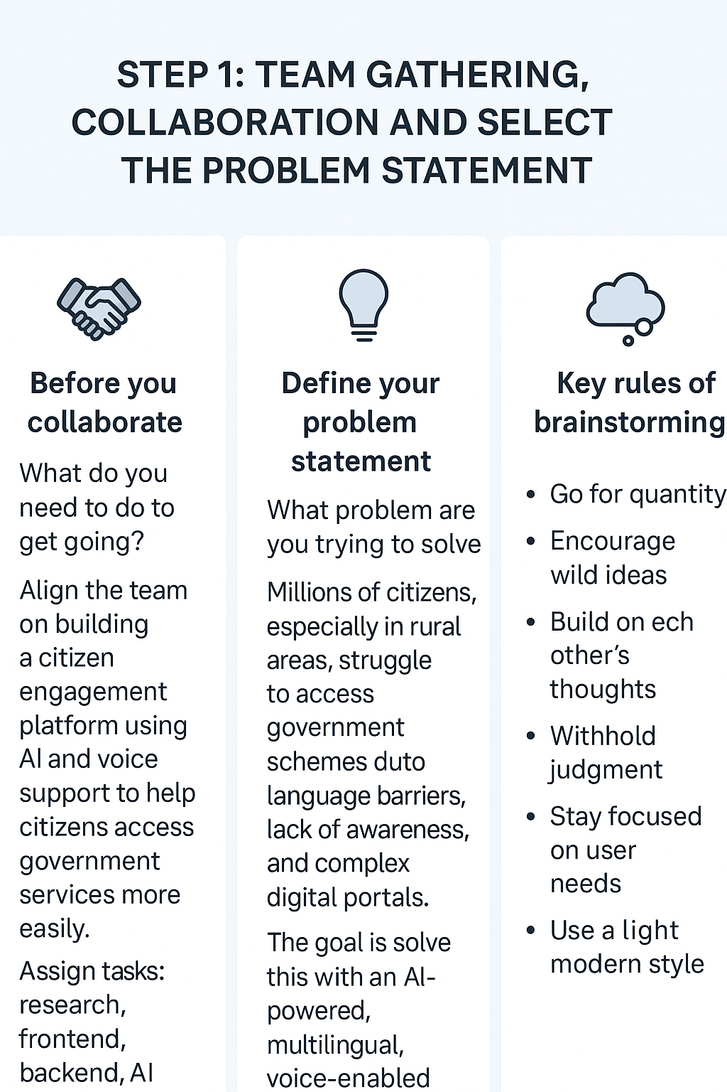

**Step-2: Brainstorm, Idea Listing and Grouping:**

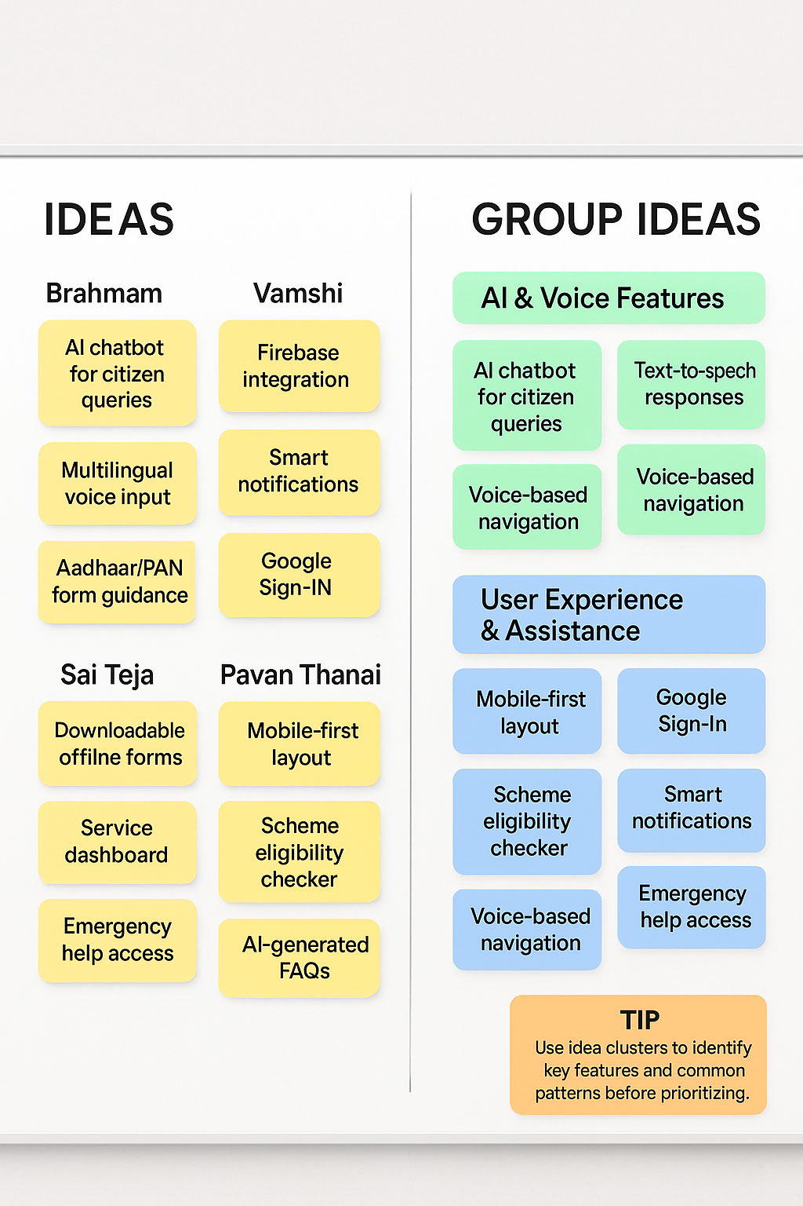

**Step-3: Idea Prioritization**

